EX NO: 4 K MANOJ KIRAAN
240701305

DASHBOARDS IN ZOHO CREATOR

AIM
To create an interactive Online Shopping Dashboard using Zoho Creator to monitor orders, delivery status, account status, and other important shopping information through reports and charts.

PROCEDURE
- Open the Online Shopping System application in Zoho Creator.
- Create a new Dashboard/Page for displaying shopping-related information.
- Add the required reports such as All Orders and Delivery Status to the dashboard.
- Create summary panels to display important information such as:
  - Total Orders
○ Shipped Orders
○ Cancelled Orders
○ Inactive Account Orders
- Add charts to visualize the order information, such as:
  - Order Status using a Pie Chart
○ Account Status using a Bar Chart
○ Delivery Status using a Chart
- Arrange the reports, charts, and summary panels properly on the dashboard.
- Add a search option to easily find the required order information.
- Preview the dashboard and verify that the reports and charts display the correct order data.

OUTPUT

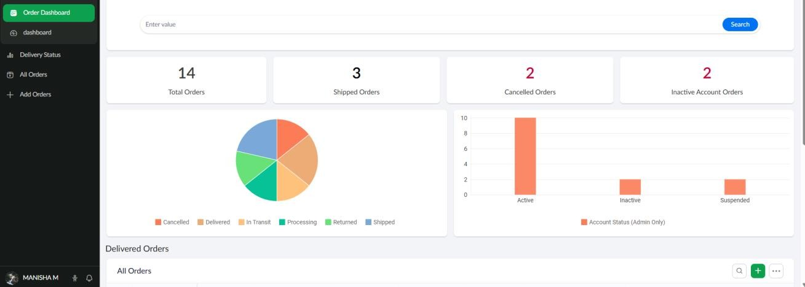

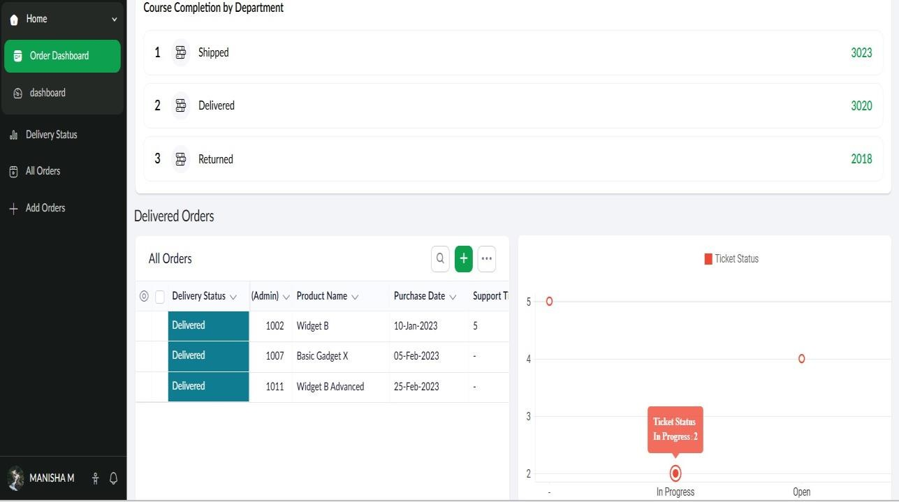

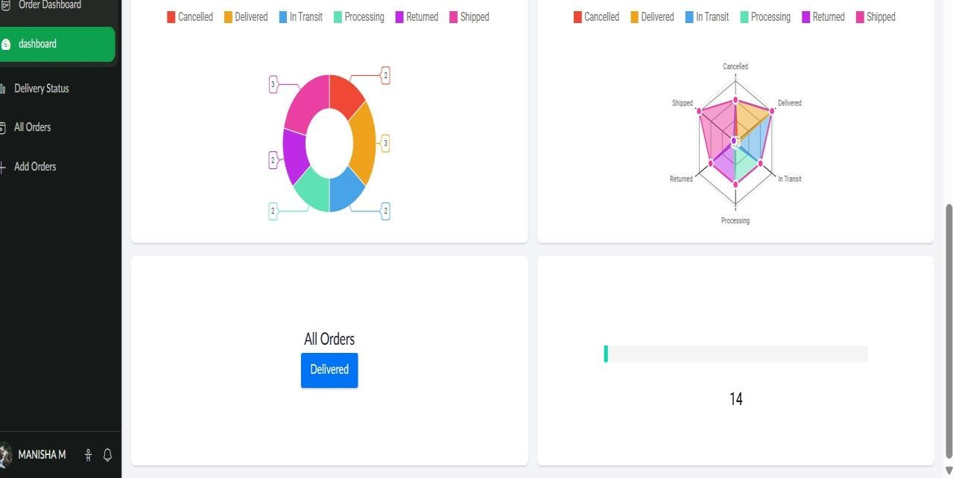
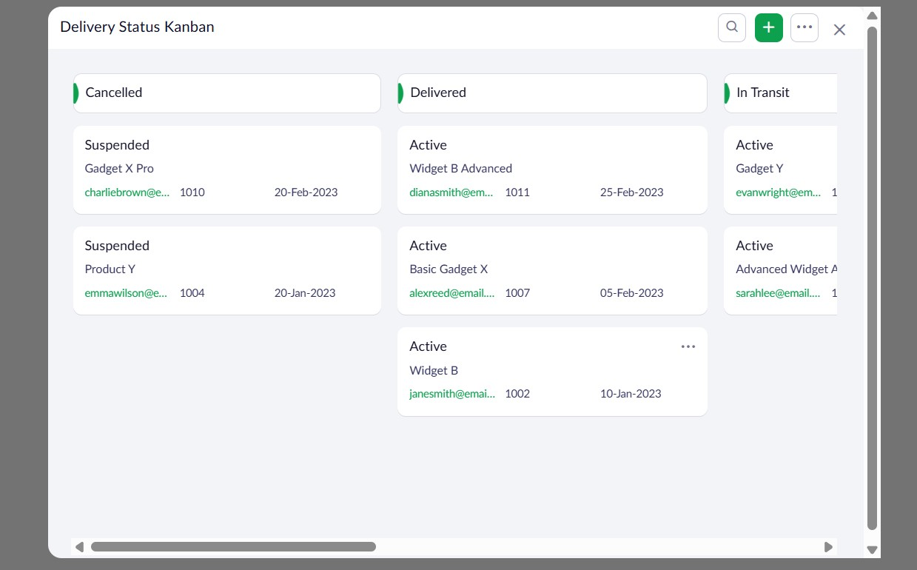

RESULT
Thus, an interactive Online Shopping Dashboard was successfully created in Zoho Creator to monitor orders, delivery status, account status, and other shopping-related information using reports, charts, and summary panels.

